Lesson 3 Demo 5: Adding Changes to the Last Commit

This section will guide you to:

* Add changes to the last commit

This lab has six subsections, namely:

1. Checking the list of files in the repository
2. Opening the file in the vi editor to implement the necessary changes
3. Executing **git status** to check the status of the repository**.** It shows that the file is being modified
4. Using **git add** command to add the files to the staging area
5. Executing **git commit --amend** to modify the most recent commit
6. Executing **git log --oneline** to check the recent commit with the modified message

**Please note**: Make sure you have successfully completed Lesson 3 Demo 4.

**Step 1:** Checking the log of the recent commits

* Execute **git log --oneline** to know the latest commit

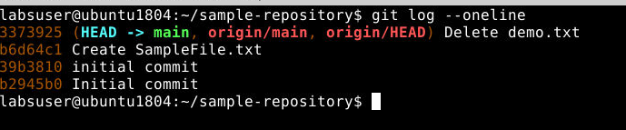

**Step 2:** Opening a file in the **vi editor** to make necessary changes



**Step 3:** Executing **git status** to check the status of the repository**.** It shows that the file is being modified

**git status**

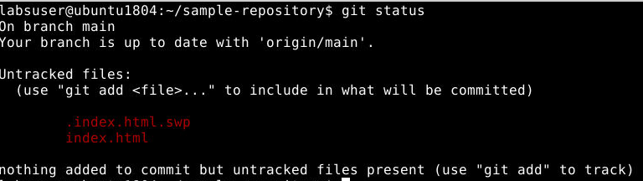

**Step 4:** Using **git add .** command to add the files to the staging area



**Step 5:** Executing **git commit --amend** to modify the most recent commit



* Editing the commit message in the text editor that shows up after executing the **“amend”** command. For instance, the commit message can be **“Added style tags in the code”**

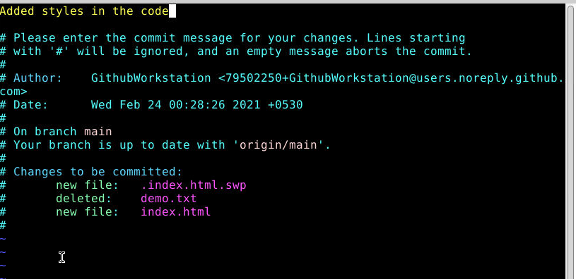

**Step 6:** Executing **git log --oneline** to check the recent commit with the modified message

